🚀 Deploy a Java Maven WebApp to Apache Tomcat and Push to GitHub

🧰 Prerequisites

Install the required tools:

# Update packages

sudo apt update

# Install Java

sudo apt install default-jdk -y

# Install Maven

sudo apt install maven -y

📦 Install and Configure Apache Tomcat

cd /opt

wget https://dlcdn.apache.org/tomcat/tomcat-10/v10.1.42/bin/apache-tomcat-10.1.42.tar.gz

Extract the tar file

tar xzf apache-tomcat-10.1.42.tar.gz

mv apache-tomcat-10.1.42 tomcat

chmod +x /opt/tomcat/bin/*.sh

/opt/tomcat/bin/startup.sh

Access Tomcat at:

👉 <http://server-ip:8080>

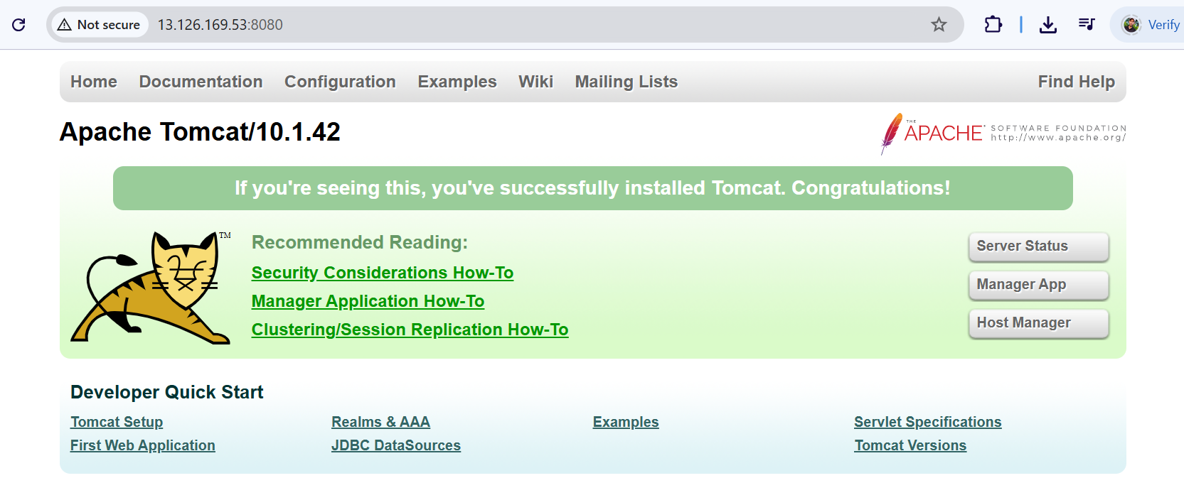

📁 Create Sample Java WebApp with Maven

mvn archetype:generate -DgroupId=com.example -DartifactId=sample-webapp \

-DarchetypeArtifactId=maven-archetype-webapp -DinteractiveMode=false

cd sample-webapp

🛠 Update pom.xml

<project xmlns="http://maven.apache.org/POM/4.0.0"

xmlns:xsi="http://www.w3.org/2001/XMLSchema-instance"

xsi:schemaLocation="http://maven.apache.org/POM/4.0.0 http://maven.apache.org/xsd/maven-4.0.0.xsd">

<modelVersion>4.0.0</modelVersion>

<groupId>com.example</groupId>

<artifactId>sample-webapp</artifactId>

<version>1.0-SNAPSHOT</version>

<packaging>war</packaging>

<name>Sample WebApp</name>

<dependencies>

<dependency>

<groupId>javax.servlet</groupId>

<artifactId>javax.servlet-api</artifactId>

<version>4.0.1</version>

<scope>provided</scope>

</dependency>

</dependencies>

<build>

<finalName>sample-webapp</finalName>

<plugins>

<plugin>

<groupId>org.apache.maven.plugins</groupId>

<artifactId>maven-war-plugin</artifactId>

<version>3.4.0</version>

</plugin>

</plugins>

</build>

</project>

🧾 Create a Simple Servlet

mkdir -p src/main/java/com/example

nano src/main/java/com/example/HelloServlet.java

package com.example;

import javax.servlet.*;

import javax.servlet.http.*;

import java.io.IOException;

public class HelloServlet extends HttpServlet {

protected void doGet(HttpServletRequest req, HttpServletResponse resp)

throws ServletException, IOException {

resp.getWriter().write("Hello from Maven WebApp deployed on Tomcat!");

}

}

⚙️ Configure web.xml

mkdir -p src/main/webapp/WEB-INF

nano src/main/webapp/WEB-INF/web.xml

<web-app xmlns="http://java.sun.com/xml/ns/javaee"

version="3.0">

<servlet>

<servlet-name>hello</servlet-name>

<servlet-class>com.example.HelloServlet</servlet-class>

</servlet>

<servlet-mapping>

<servlet-name>hello</servlet-name>

<url-pattern>/hello</url-pattern>

</servlet-mapping>

</web-app>

🏗️ Build the WAR File

mvn clean package

Output:

target/sample-webapp.war

🚀 Deploy WAR to Tomcat

sudo cp target/sample-webapp.war /opt/tomcat/webapps/

/opt/tomcat/bin/shutdown.sh

/opt/tomcat/bin/startup.sh

Access the application:

http://<your-server-ip>:8080/sample-webapp/

